Application Version of HDD-OSD + KERMIT + Tutorial
by yeshuachrist » Sun Jul 14, 2013 6:43 am
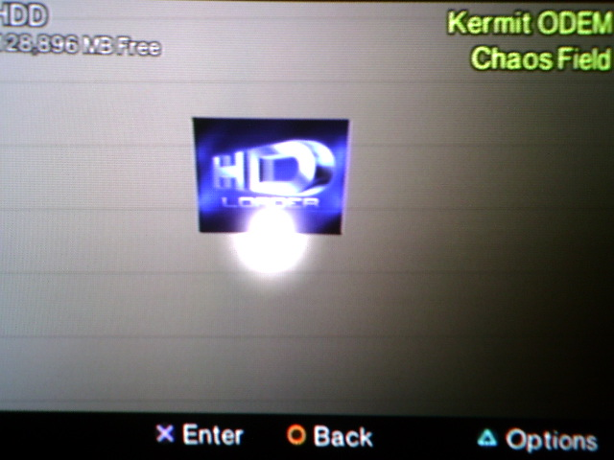
First let me say, there are a lot of very large packs floating around to help you use "HDD-OSD" but you don't need to download such large files to use "HDD-OSD". We have a Application Version that is very easy to use all you have to do is drag and drop the files in the two folders into the right folders created by formatting your Hard Drive with "WinHIIP 1.7.6". Once you do that the program will work fine, and you can even install games from "WinHIIP 1.7.6" and use "HDD-OSD" to boot them, using this tutorial. And you didn't have to download a few gigs to do it, just this small pack, Amazing Right?!
Whats Included:
1. HDD-OSD - Auto ATAD patch + 48bit patch
2. KERMIT - New Save Icon, it now uses the "HDloader" ICON for all the games you patch to work with "HDD-OSD"
Tutorial
1. Format Your Harddrive with "WinHIIP_V1.7.6"
2. Add any PS2 games you want while your still in "WinHIIP_V1.7.6"
3. Using Ulaunchelf - drop the contents of the "_sysconf" folder into your "_sysconf" folder, and the contents of the "_system" folder into your "_system" folder.
4. Dump the Contents of KERMIT into the root of your memory card, and then run the program from Ulaunchelf, Then Patch all your games - Once in KERMIT go to, "ODEM Manager" and press CIRCLE and scroll down to "install hdd-osd data" and hit CIRCLE, then confirm it with SQUARE, and your done
5. Go back to Ulaunchelf, now select the "hosdsys" file that is in the _system/osd100 folder and now you will be taken back to the ODSYS browser, select "Browse" now you can see all your games and now you can launch each one !!!
Miscellaneous
I'm using the FMCB exploit to launch ulaunchelf, and this is how I launch "HDD-OSD" as an app, without having to format my harddrive, or use "hdd copy" because "HDD-OSD" does not need the MBR table to run or boot games with KERMIT's injection of Mini-OPL. So there is no need to downloads a gigabyte sized file just to run "HDD-OSD". Enjoy hopes this helps, once again you do not need to reformat your harddrive to use this setup, just copy/paste the files and run it from ulaunchelf. (HDD-OSD is under reporting the size of your harddrive because were not using the MBR to launch the program, otherwise your drive size is fine just fill it up and use it, this setup is great for checking out HDD-OSD before you attempt to do a larger install using the MBR (master boot record/table).
DOWNLOAD HERE
http://www.theisozone.com/downloads/playstation/ps2-homebrew/application-version-of-hdd-osd-kermit/

